Make Address field length to 200 alpha numeric. Should have Address 1, Address 2 And Address 3 structure – see surveyor Master

System Admin

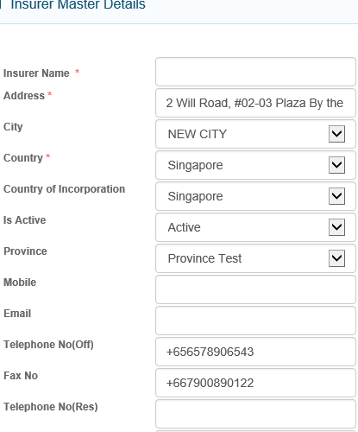

City Master not available in Admin – City picker?

200 alpha numeric and accept unicodes

Default Singapore. Drop down list from Country master in alpha order

Default Singapore. Drop down list be World Country, in alpha order

Move this field to the end, below Remarks. Default to Active when creating New

Move Postal Code field below Country

REMOVE Province and Mobile

REMOVE Telephone No(Res)

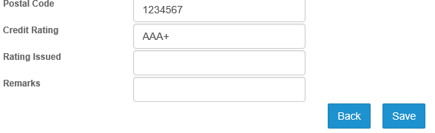

Change field name to – Year Rating Issued

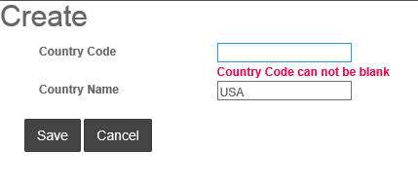

Country Code – auto system generated – from CO001

What is the difference these 2 Save and Back button colors – Black and Blue

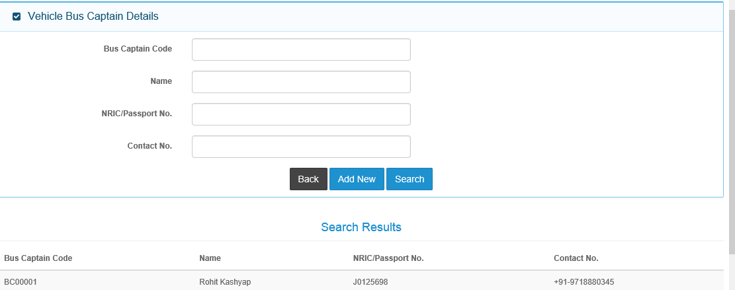

Include New search result column - Nationality

This default screen should be consistent with the rest.

Search by Bus Captain Name and NRIC/Passport No.

This block should display when click Add New button, which is not displaying currently.

New Field below NRIC/Passport No. – Nationality – 100 chars

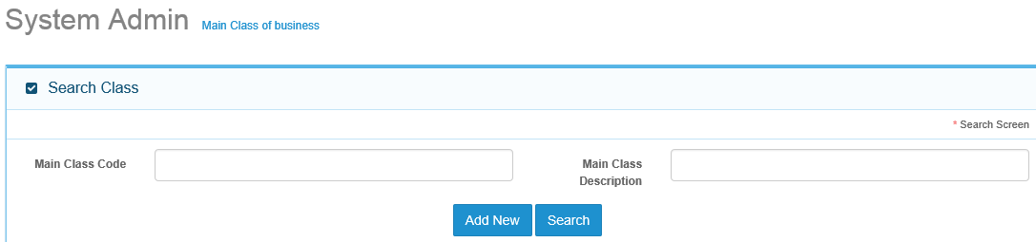

Search By Main Class – provide Drop down selection, join Description with Code

Main Class Code search not required

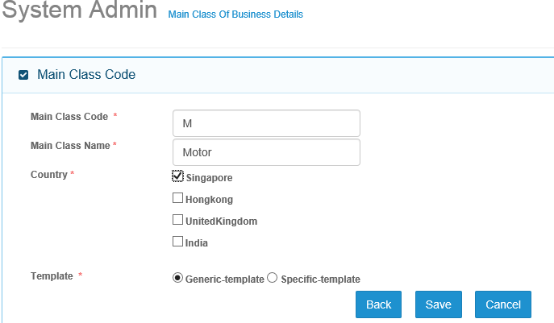

Insert New Field – Status – default to Active.

Option is Active/Inactive. If Inactive, this Main Class is not available for transactions processing.

Country and Template fields to remove

Main Class Description

Main Class Code is System generated and fixed – non-editable – M for Motor

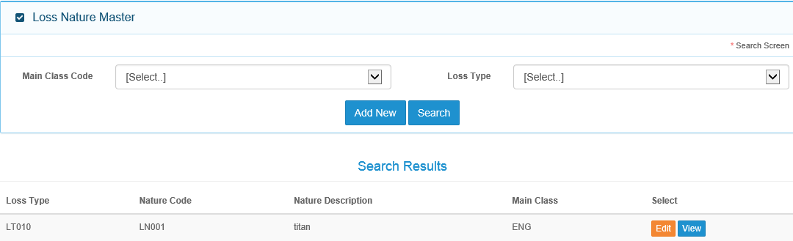

Main Class Description

New Column – Sub-Class Description

New Field – Sub Class

Drop down selection by Main Class Description, not Code

Not required. To remove

Loss Nature Code

Should be Loss Nature, not search by Loss Type

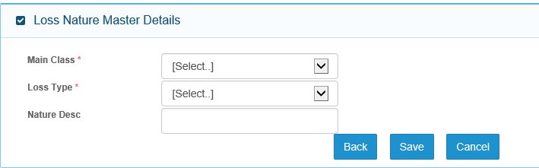

Loss Nature

And not mandatory if Add New

Loss Nature Description

New Field below Main Class Description – Sub-Class Description – dropdown sel

When click Save, system generates Loss Nature code, starting from LN001

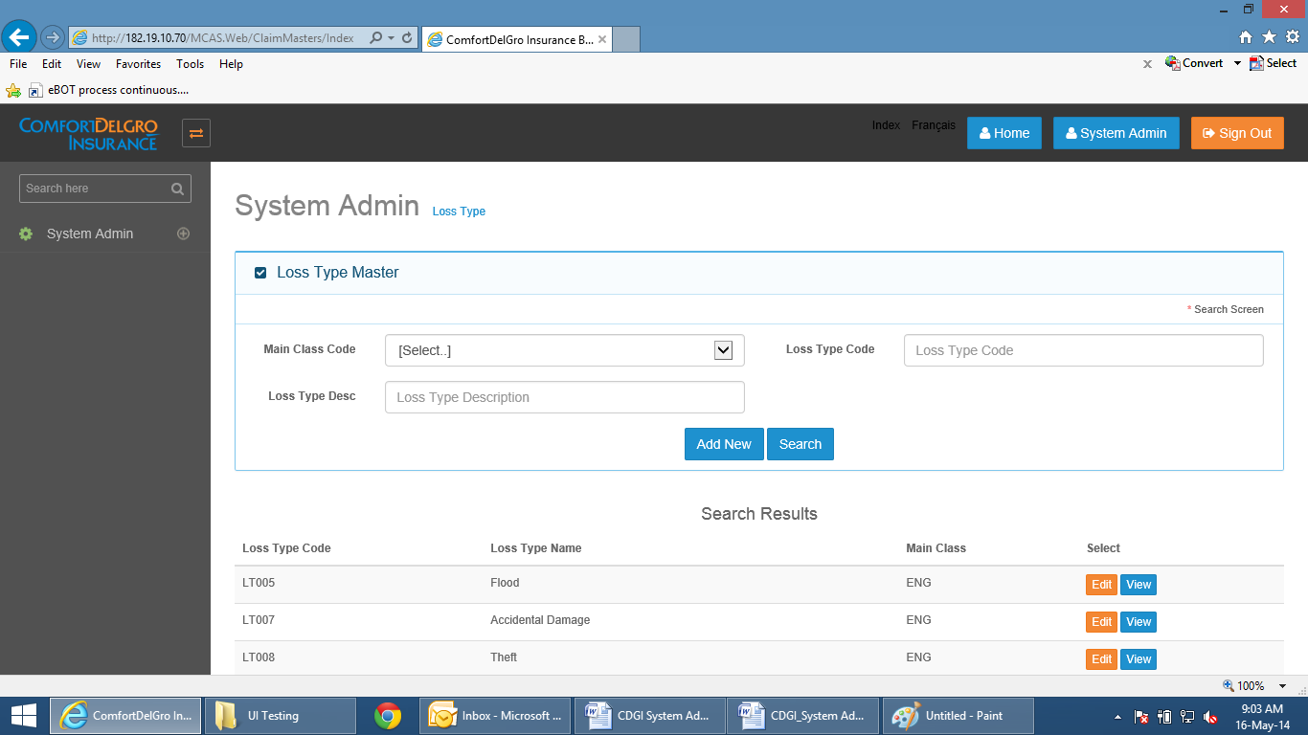

Main Class Description

New Column – Sub-Class Description

Drop down selection

New Field – Sub-Class Description – drop down sel

Main Class Description, not Code

Main Class Description

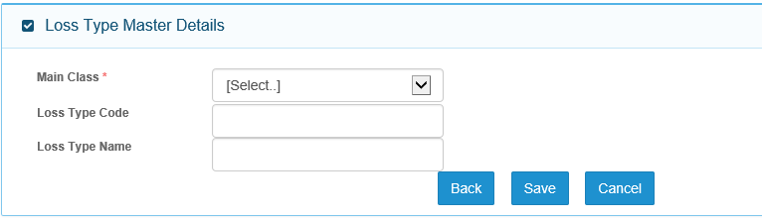

When click on Save button, system auto generates Loss Type Code starting from LT001

Loss Type Description

New field Sub-Class Description – drop down sel

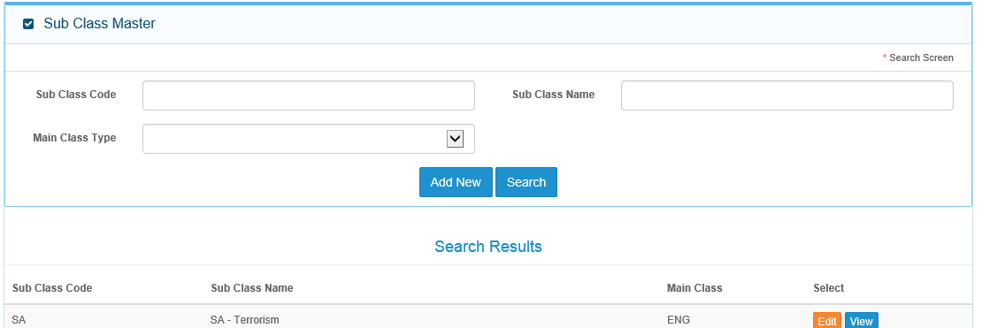

Search by Cub Class Description – provide drop down selection, join Description with Code

Search by Sub Class Code not required

Move this column closer

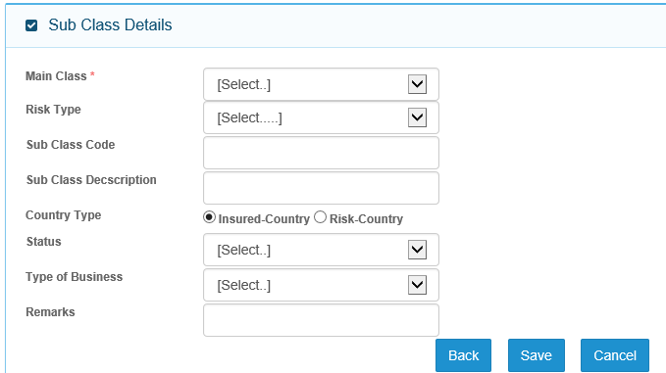

Risk Type and Country Type - Not required. To remove

Sub Class Code is user entry and is 4 char code.

First char must equal main Class Code, in this case “MZZZ”

DEPOT MASTER – SCREEN NOT AVAILABLE – 17 May.

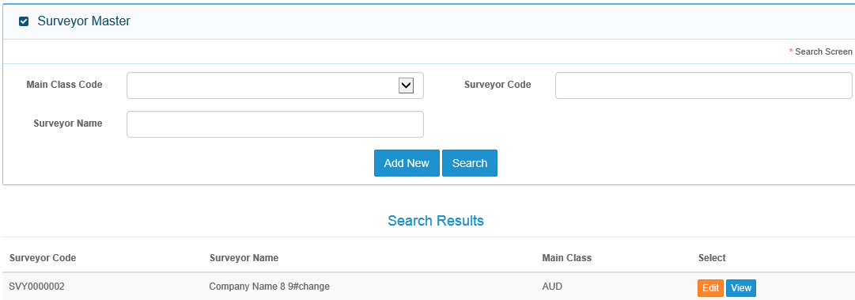

Replace Main Class column with Status

Search by Surveyor Name – provide drop-down selection

Please remove search by Main Class.

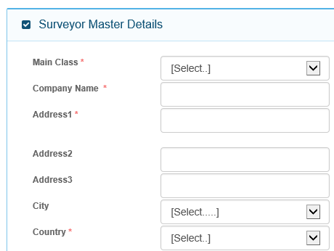

City Master not available. Have City Picker ?

Auto default to Singapore. Drop down from selection from Country Master

spacing

Pl provide 200 alpha numeric chars and Unicode acceptable

Main Class field not required as this is applicable to all Main Clas

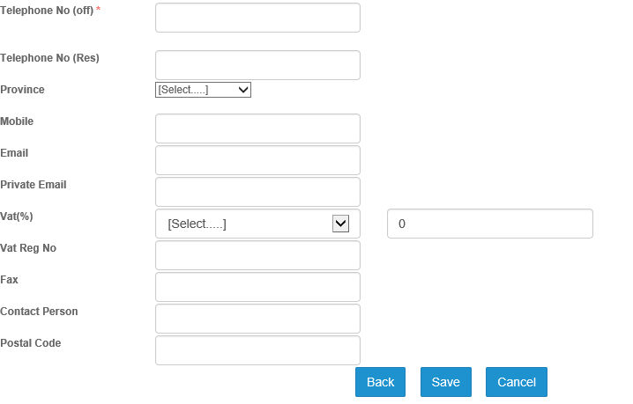

Insert New Field – Status - Active or Inactive. All new cases default to Active

Move Contact Person to above Mobile NO.

Move Fax field to below Telephone No.(off)

Postal Code – move to below Country field

GST Reg No.

Corresponding GST Rate %

Drop down from GST Setting – GST Description.

GST %

Private email field – not required

Telephone No (Res) and Province fields not required.

When click Save, system generates message that data successfully saved and Surveyor Code is SVY999

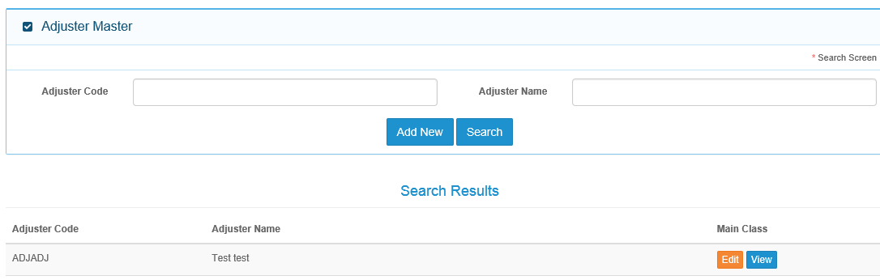

Adjuster code should be ADJ999

Same presentation as Surveyor

Main Class - remove

Status

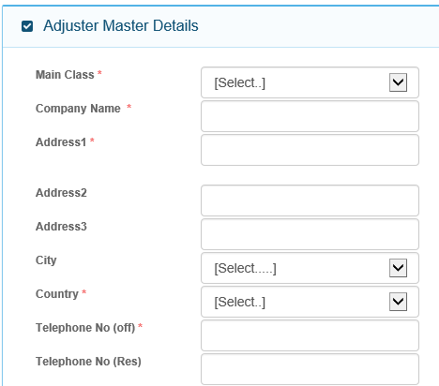 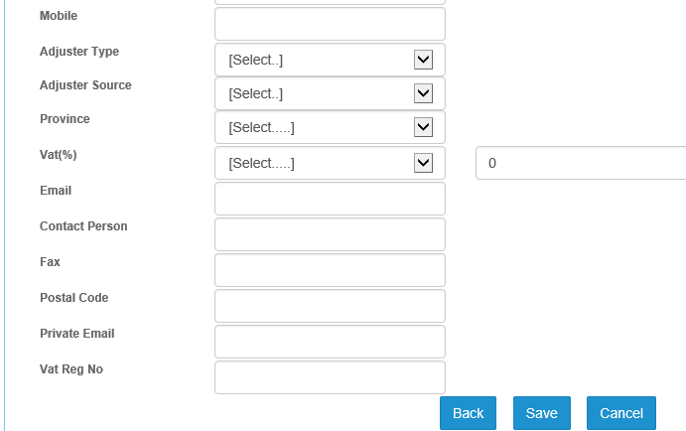

FOLLOW ARRANGEMENT OF FIELDS AND FIELD LENGTHS AS IN SURVEYOR MASTER.

ADJUSTER TYPE AND ADJUSTER SOURCE FIELDS APPEAR ON TOP, BEFORE COMPANY NAME

WHEN CLICK SAVE, SYSTEM GENERATES MESSAGE THAT DATA SUCCESSFULLY SAVED AND THAT ADJUSTER CODE IS ADJ999

Not Required

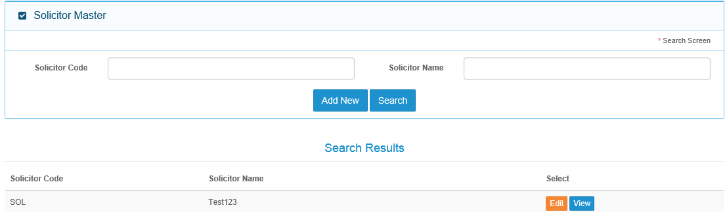

This should be SOL999

Status column

Search by Solicitor Name – drop down selection

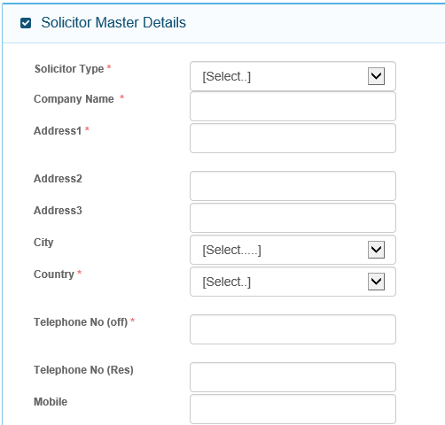

Follow arrangements of field names and field lengths as in Surveyor Master

Upon click Save, message displayed that data successfully saved and that Solicitor Code is SOL999

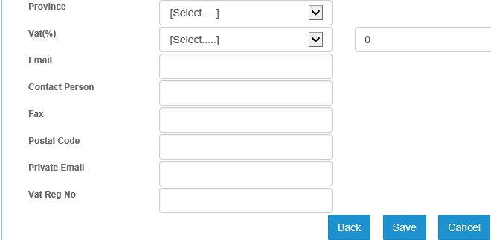

Search by Claims Expense Description – provide drop down selection

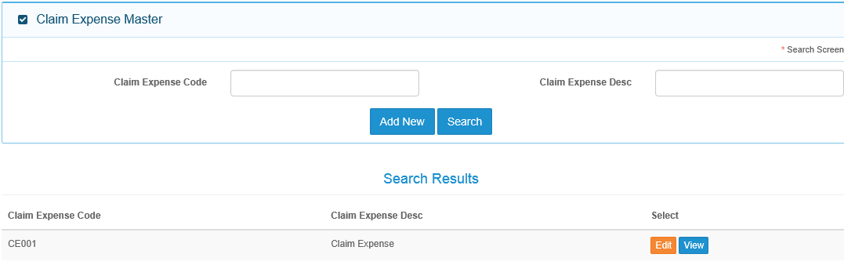

50 chars.

Auto-generate code when click Save – CE001

Message display data that successfully saved and Claims Expense Code is CE999

Claims Expense Description

Claims Expense Master and Claims Expense Code

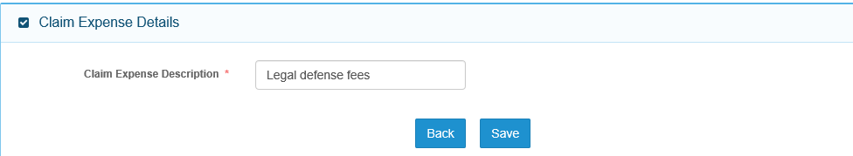

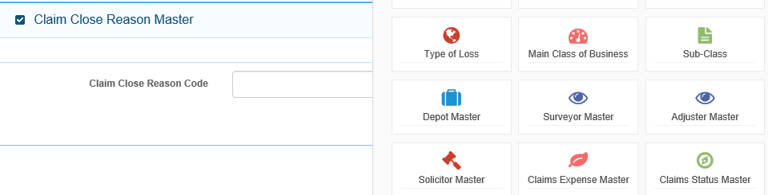

Change Claims Status Master to Claims Close Reason Master

Claims Close Reason

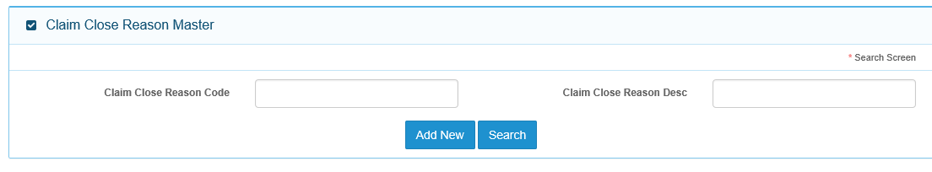

Search by Claims Close Reason Description. Can you please implement Quick search for all fields – user just need to key in first few chars and system can display search results

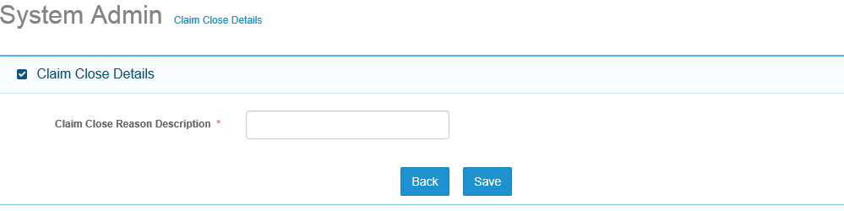

When click on Save, system will generate message that data successfully saved and Claims Close Reason is L001

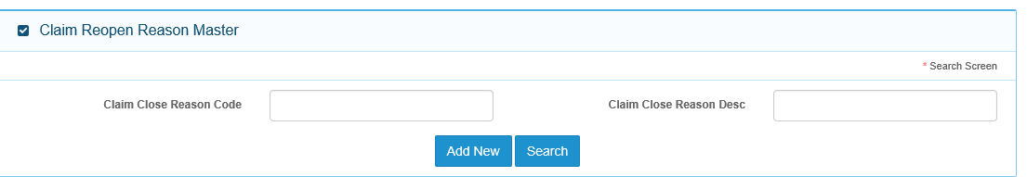

This Master table not required, please remove.

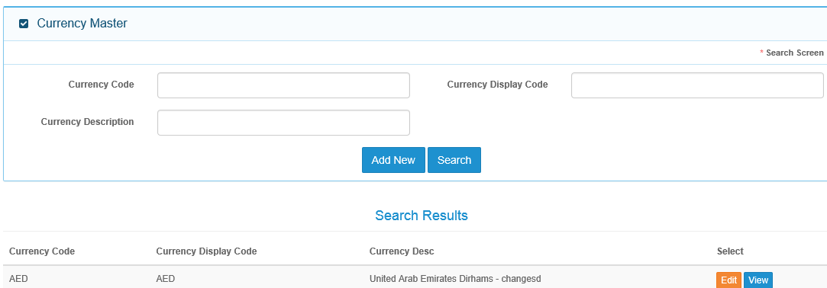

Quick search available in all fields. User keys in first few chars and system is able to search and display results

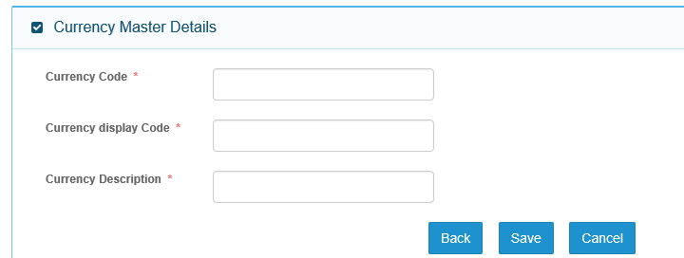

25 digits - alphanumeric

8 digits - alphanumeric

4 digits - alphanumeric

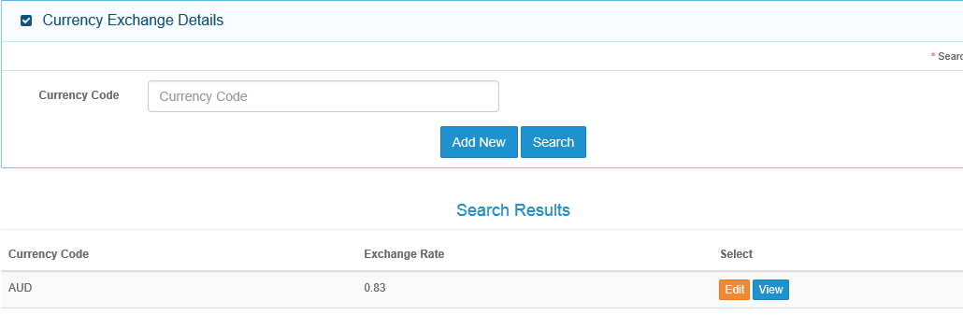

Edit function here is to allow user to change the Exchange Rate and new Effective Date. User cannot modify the Currency Code.

The system will auto update the Expiry Date of the old Exchange rate for the Currency by -1 day

When click on View, system will display all the exchange rate changes. See layout example below for USD.

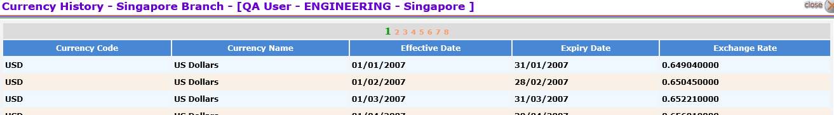

ADD NEW FUNCTION –

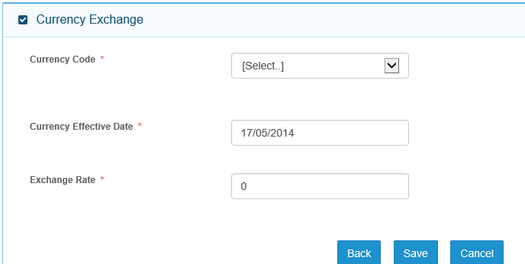

Provide to 10 decimal places. For calculation, round to nearest 2 decimal places

Defaults to current date but user can over-write

EDIT FUNCTION –

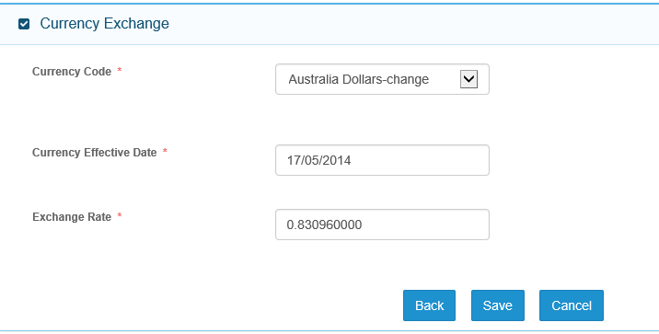

User enters new exchange rate and Currency Effective Date fields and system auto updates Expiry date of the old exchange rate by -1 day of the new Effective Date exchange rate.

User cannot have two exchange rate modifications in the same day as system rejects any duplicate dates.

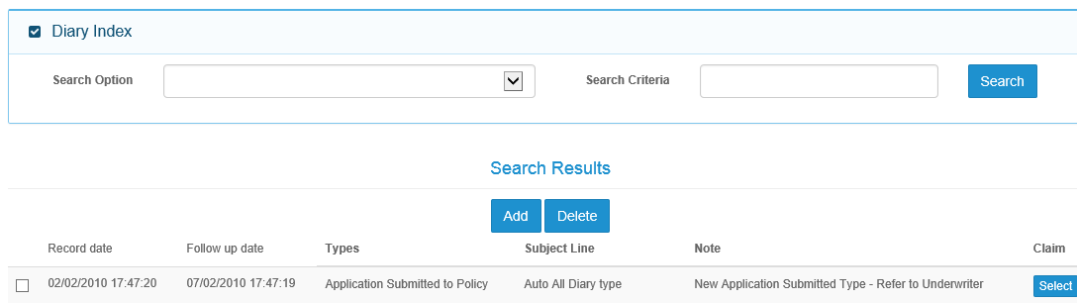

This table should be following EAW Diary concept to handle job assignment and tasks escalation

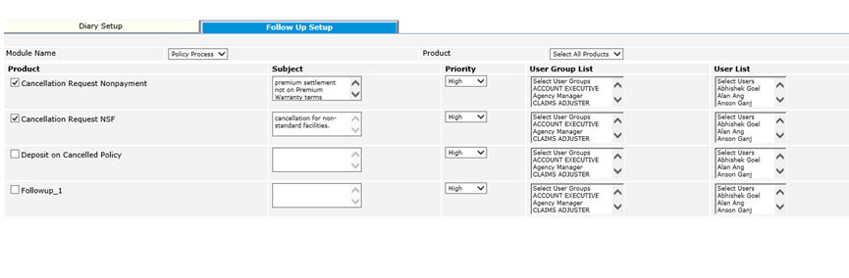

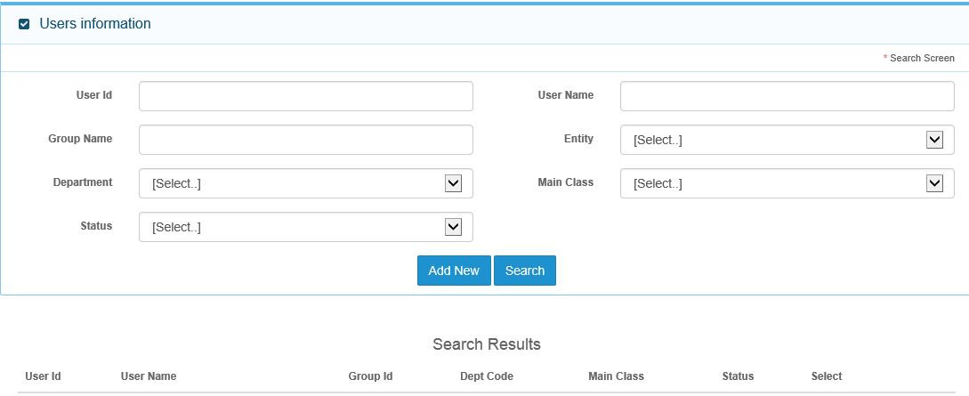

Incomplete – as at 17 May

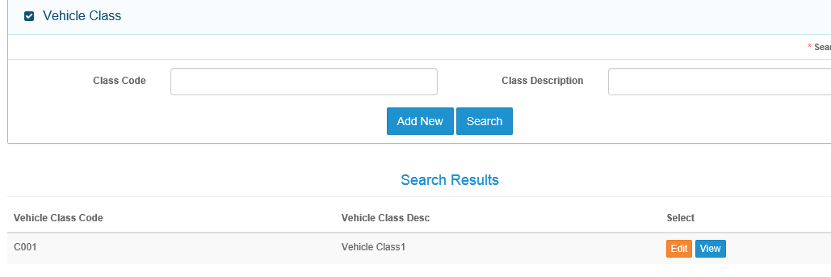

Vehicle Class Details

To include Status column

Vehicle Class Master

Amend to Vehicle Class Code and Vehicle Class Description

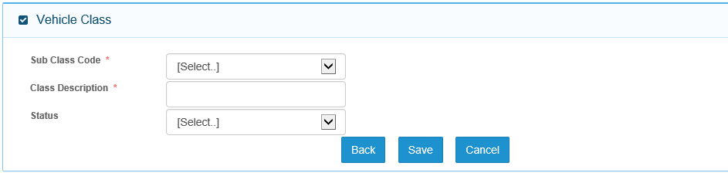

Auto default to Active for all Add New

Click on Save and system will auto generate message that data successfully saved and Vehicle Class Description is VEH001

Amend field name to Vehicle Class Description – 50 Chars

Not required. This should be Vehicle Class Code and system generated.

Amend to Vehicle Make Code and Vehicle Make Name

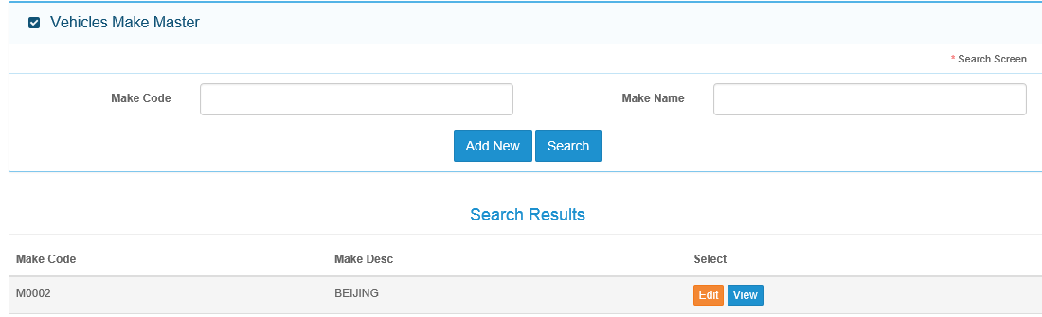

Include Status column

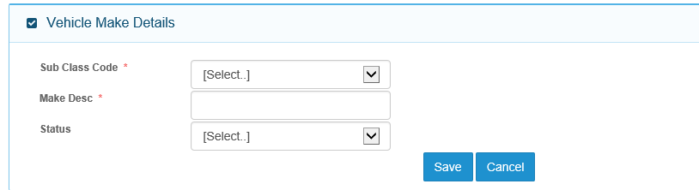

When click on Save, system auto generates message that data successfully updated and Vehicle Make Code is VEM001

Auto default to Active for all Add New cases

Amend field name to Vehicle Make Name – 100 Chars

Not Required.

Vehicle Model Master

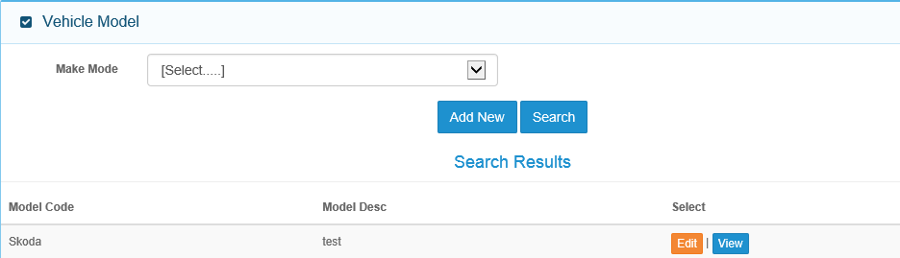

Search by Vehicle Make Name

Display search results column headers - Vehicle Make Name, Vehicle Model Description, Vehicle Model Code, Vehicle Class Description, Status and Select

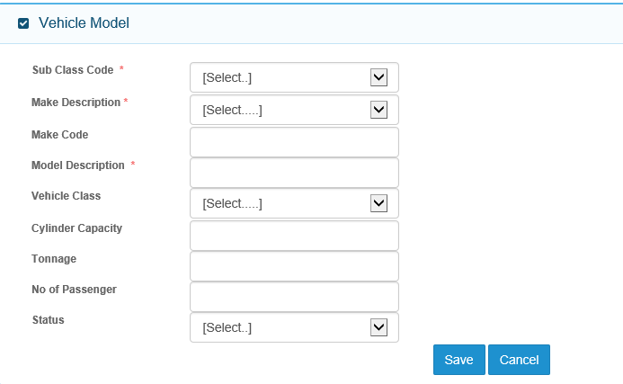

Vehicle Model Details

Vehicle Class Description, excl Inactive Vehicle Class

System auto generates message that data saved successfully and Vehicle Model Code is VED001

Status auto default to Active for Add New cases

Integers only, decimals to reject. Same for No. of Passengers

50 alpha numeric chars – Unicode accepted

Field not required

Amend field description to Vehicle Make Name – drop down selection from this master, exclude Inactive Vehicle Make

Not required.

Another search by –

Policy Effective From –From Date – To Date

This is a date range and will display all policies with Policy Effective From dates that falls within this range, inclusive.

Drop down selection from Insurer Master

Amend to Insurer

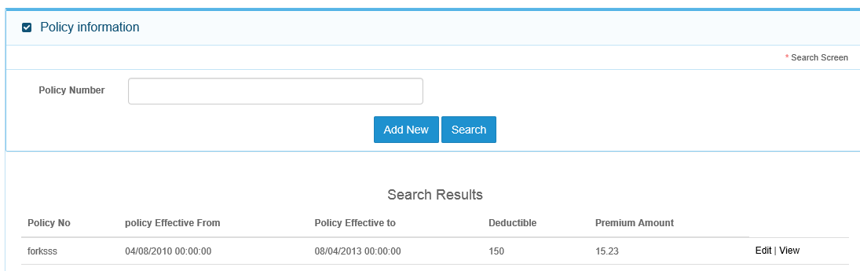

Amend Policy Effective To

Amend Policy Effective From

Time stamp not required

Insurer column first

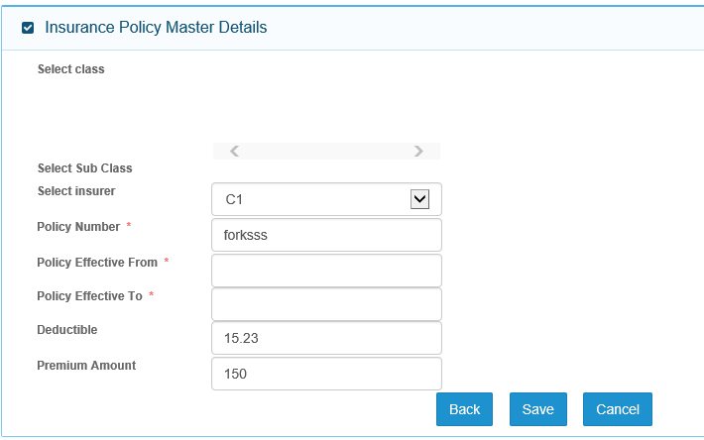

This is system computed field. A\*Premium Amount

Premium (Local Currency)

Include 2 fields – Curr and Exchange Rate below Premium

Curr – drop down selection from Currency Master, Exchange Rate will be the rate based on system date. User can over-write.

A

Curr

Include date picker

Include date picker

Main Class field – drop down selection

GST Setting Master

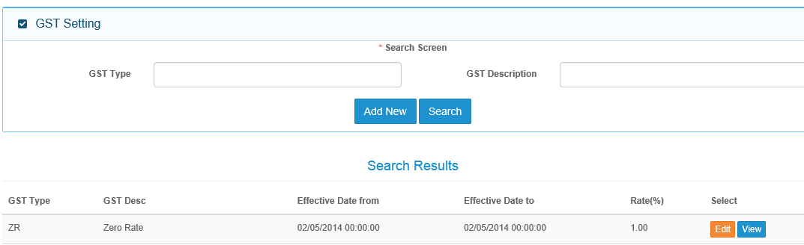

Amend to Effective Date From and Effective Date To.

Time stamp not required

Amend to GST Description

Provide drop down selection

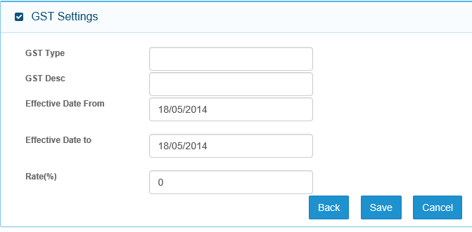

When click on Save, system generates message that GST Type saved successfully

2 decimal points

Include date picker

50 chars